Docker Commit:
Jenkins image: docker run -p 8080:8080 -p 50000:50000 jenkins
Created a docker container
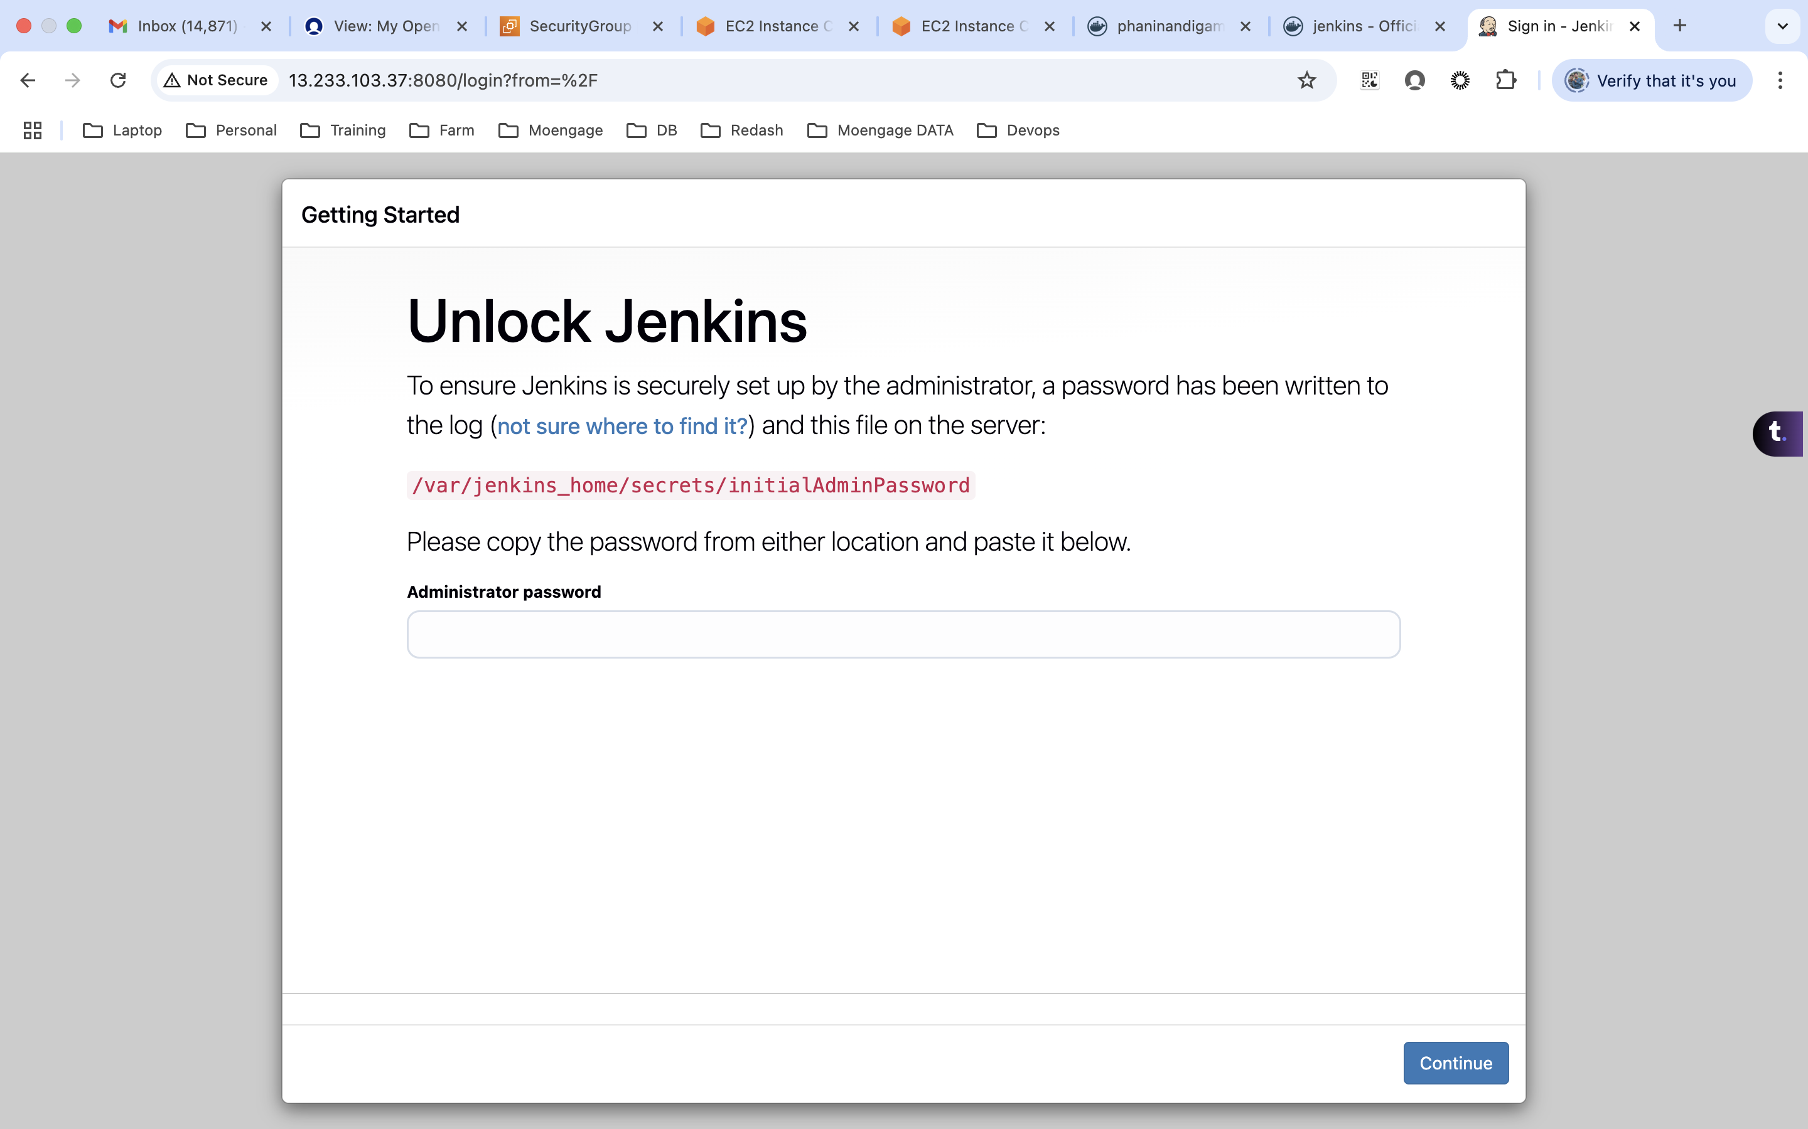

Installed plugins
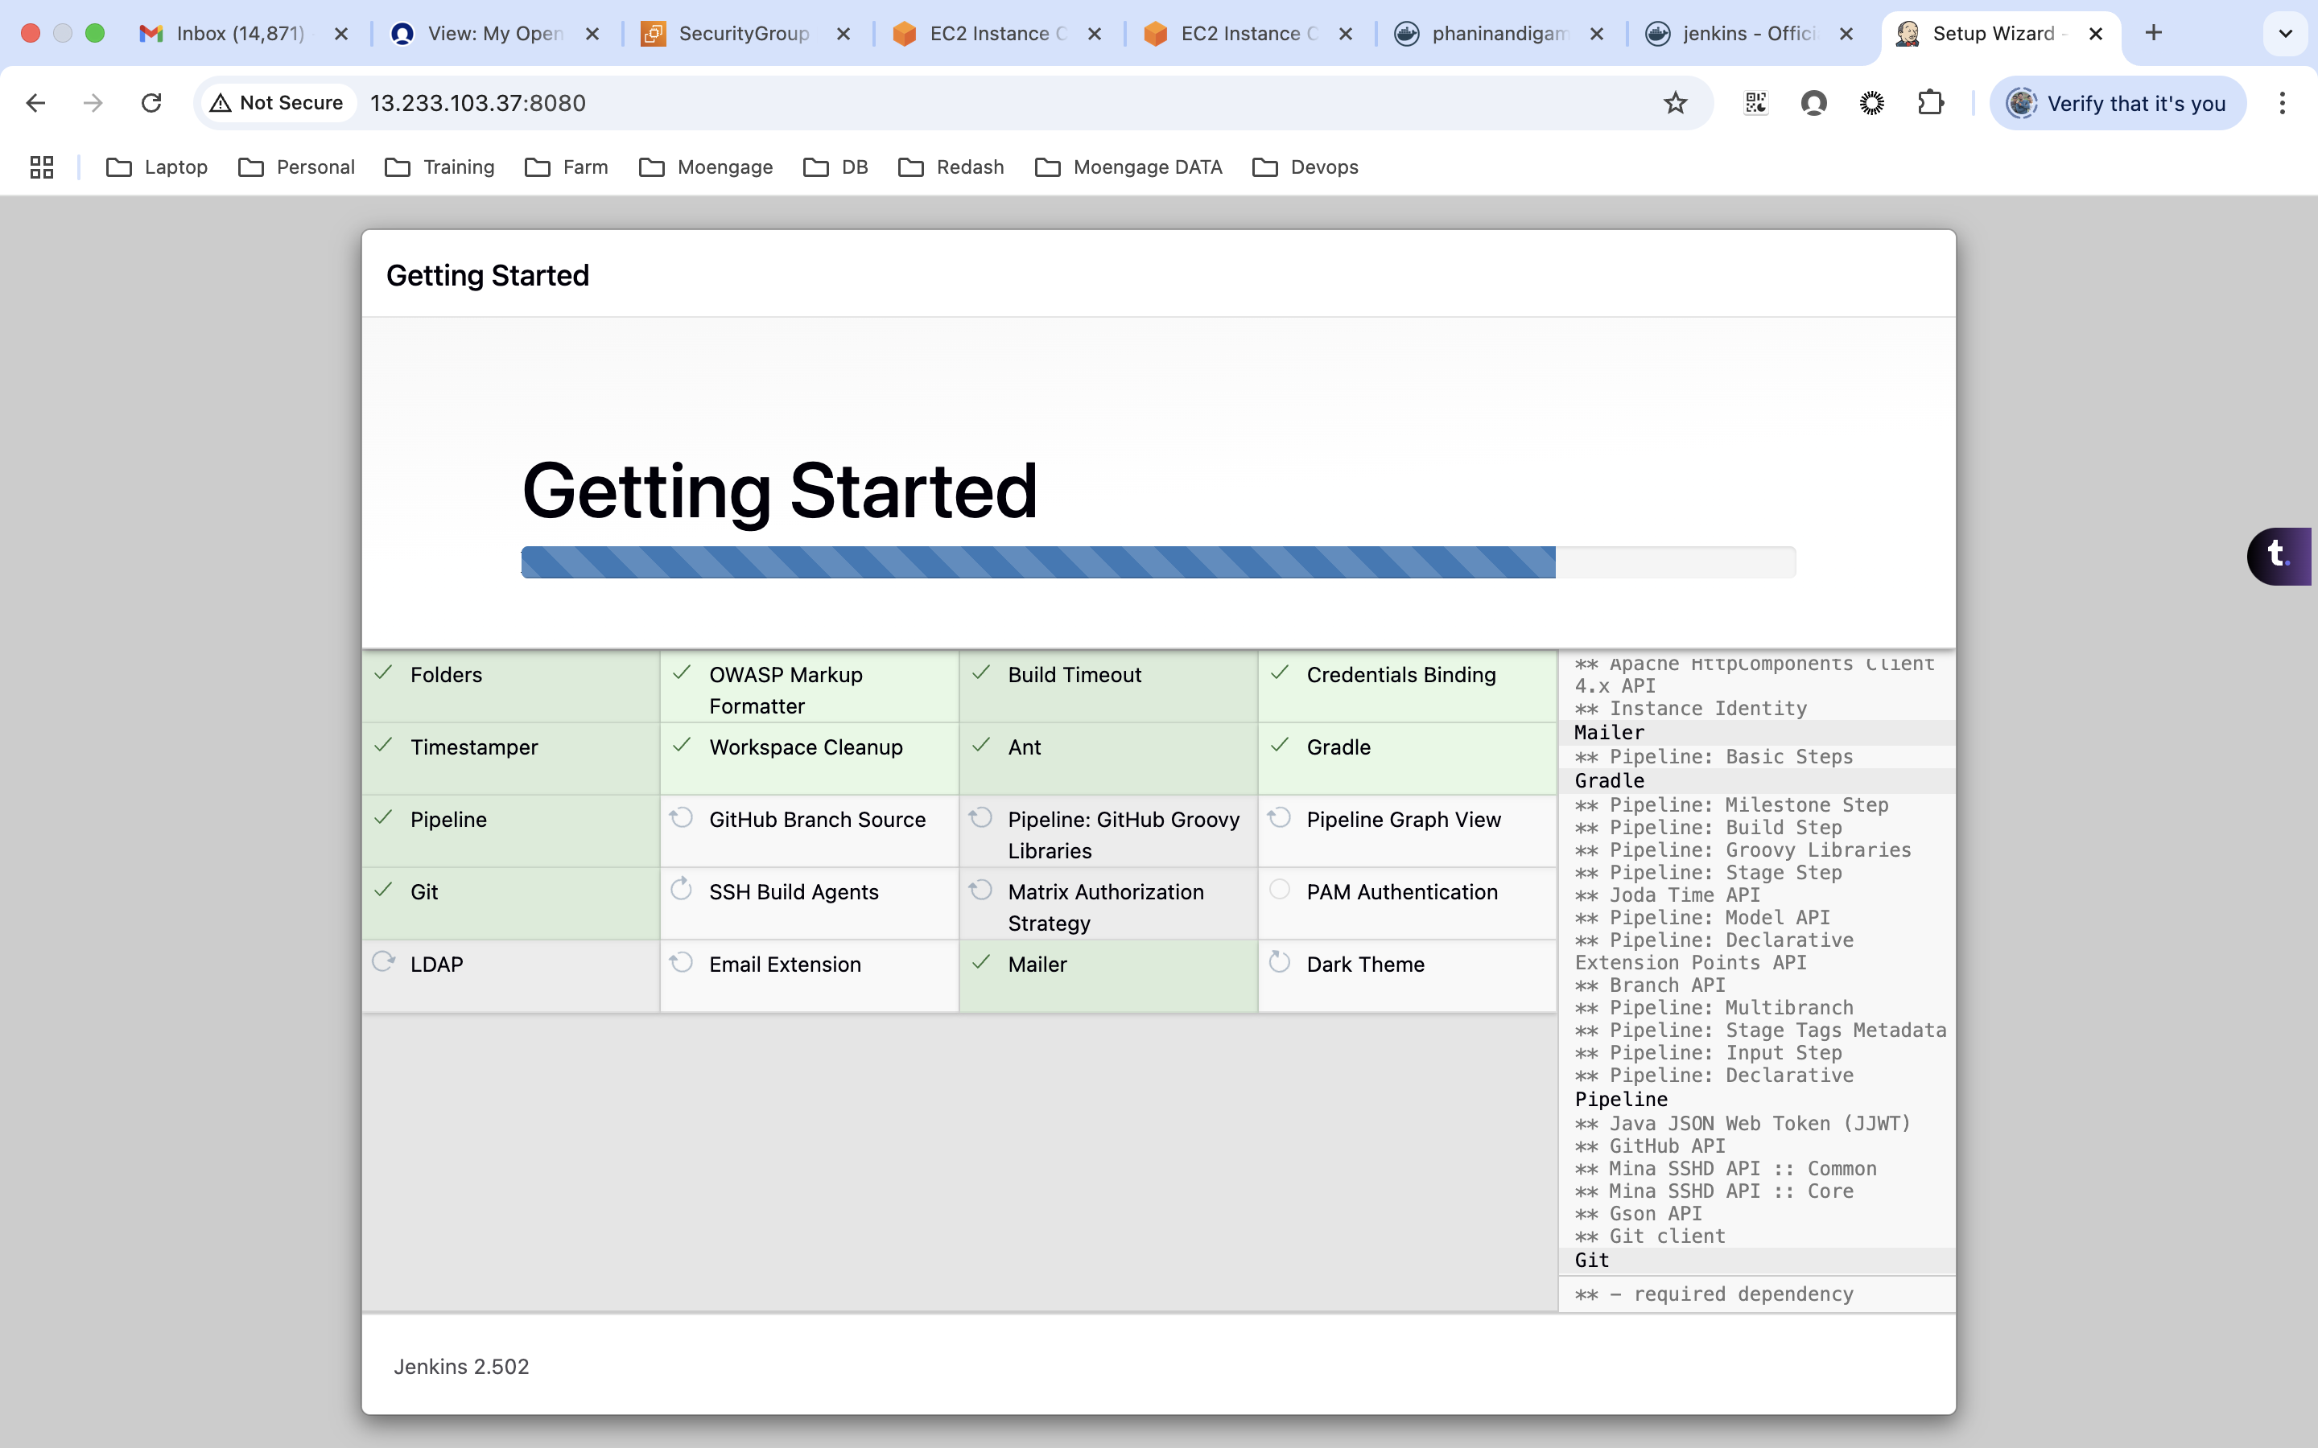

Created login credentials
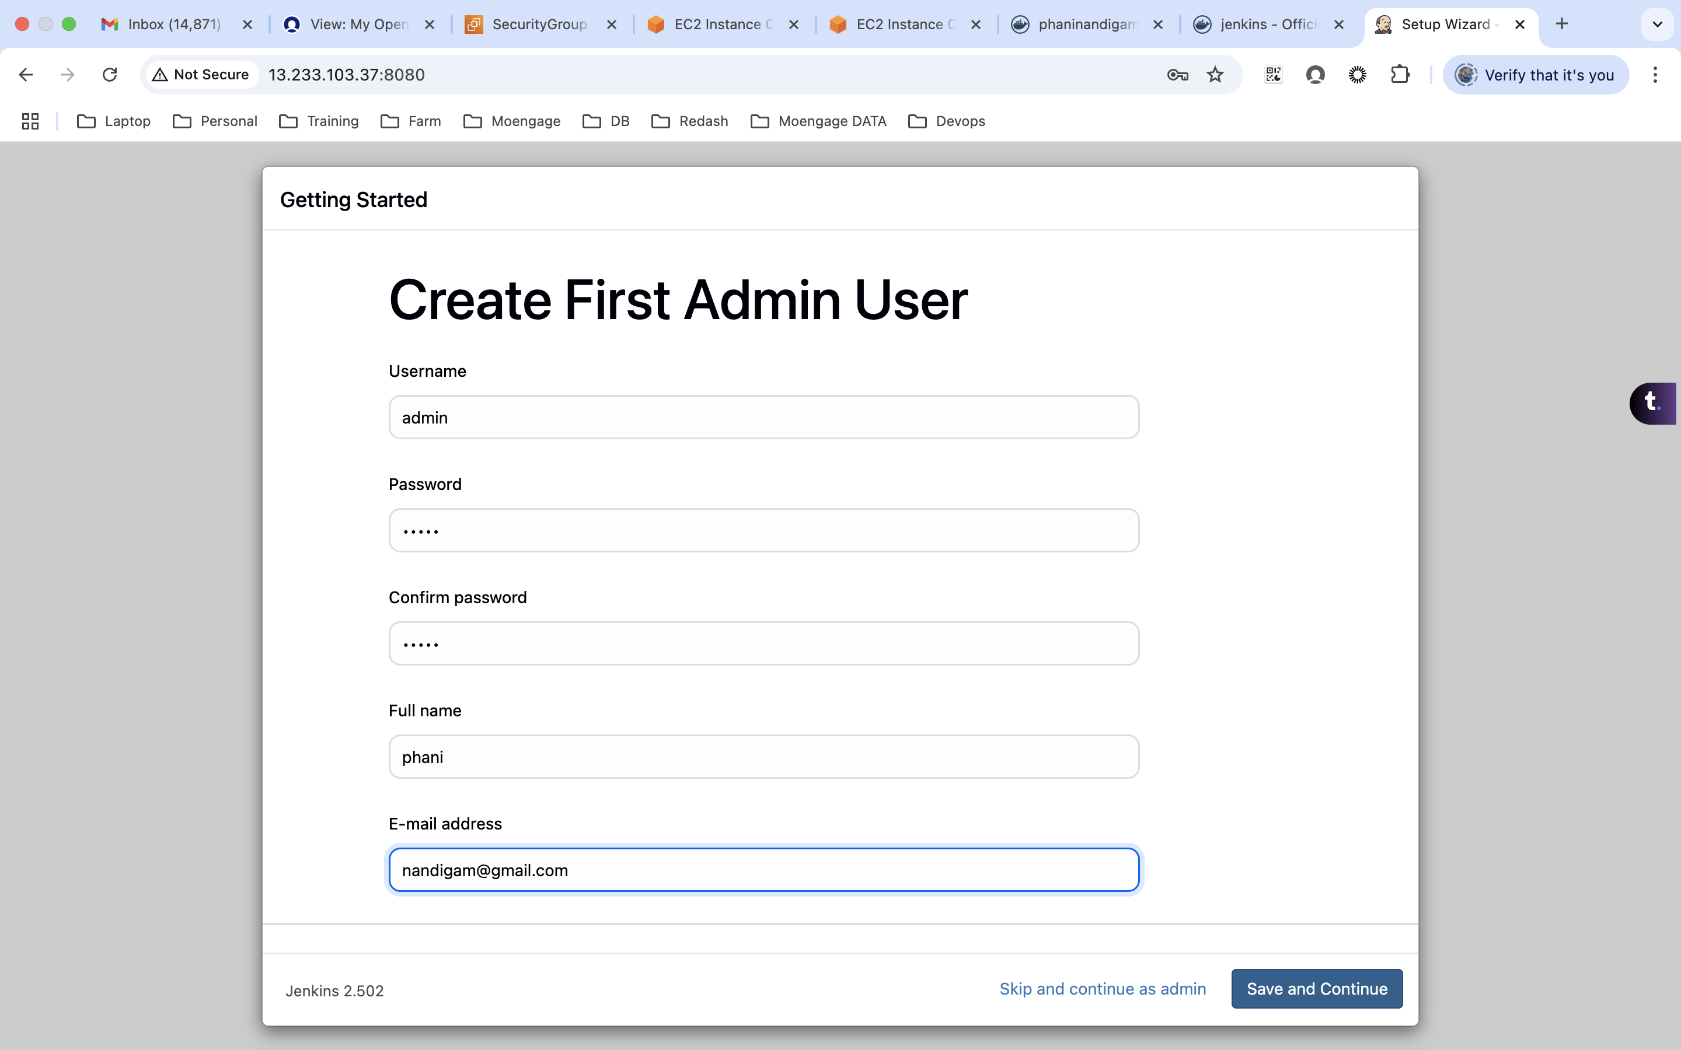

Created a free style job
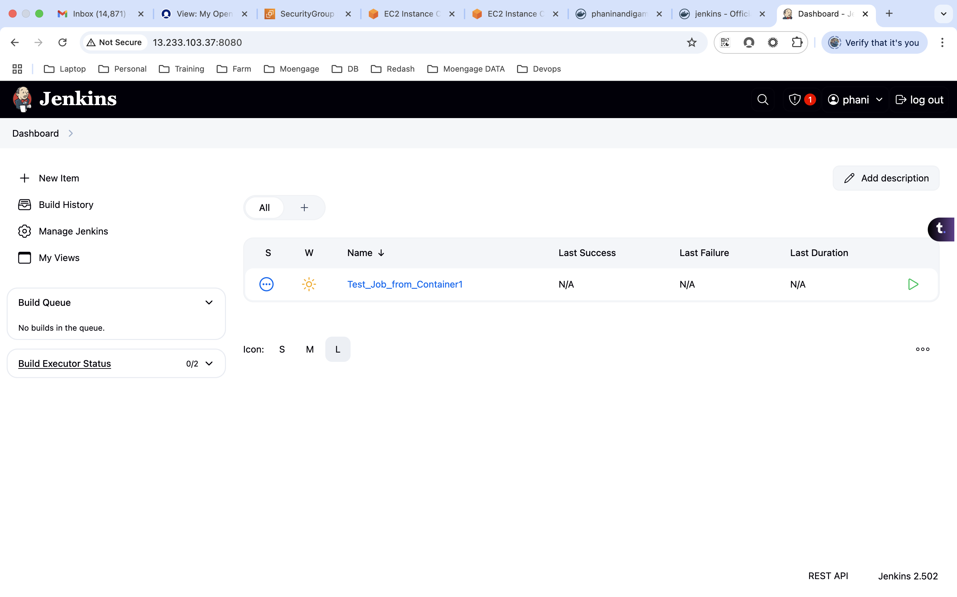
Created an image from the running container
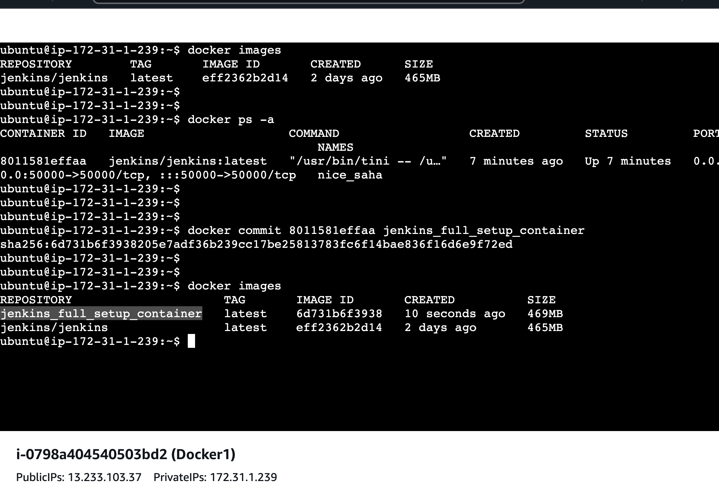

Stopped the first container and started a new one from the created image.
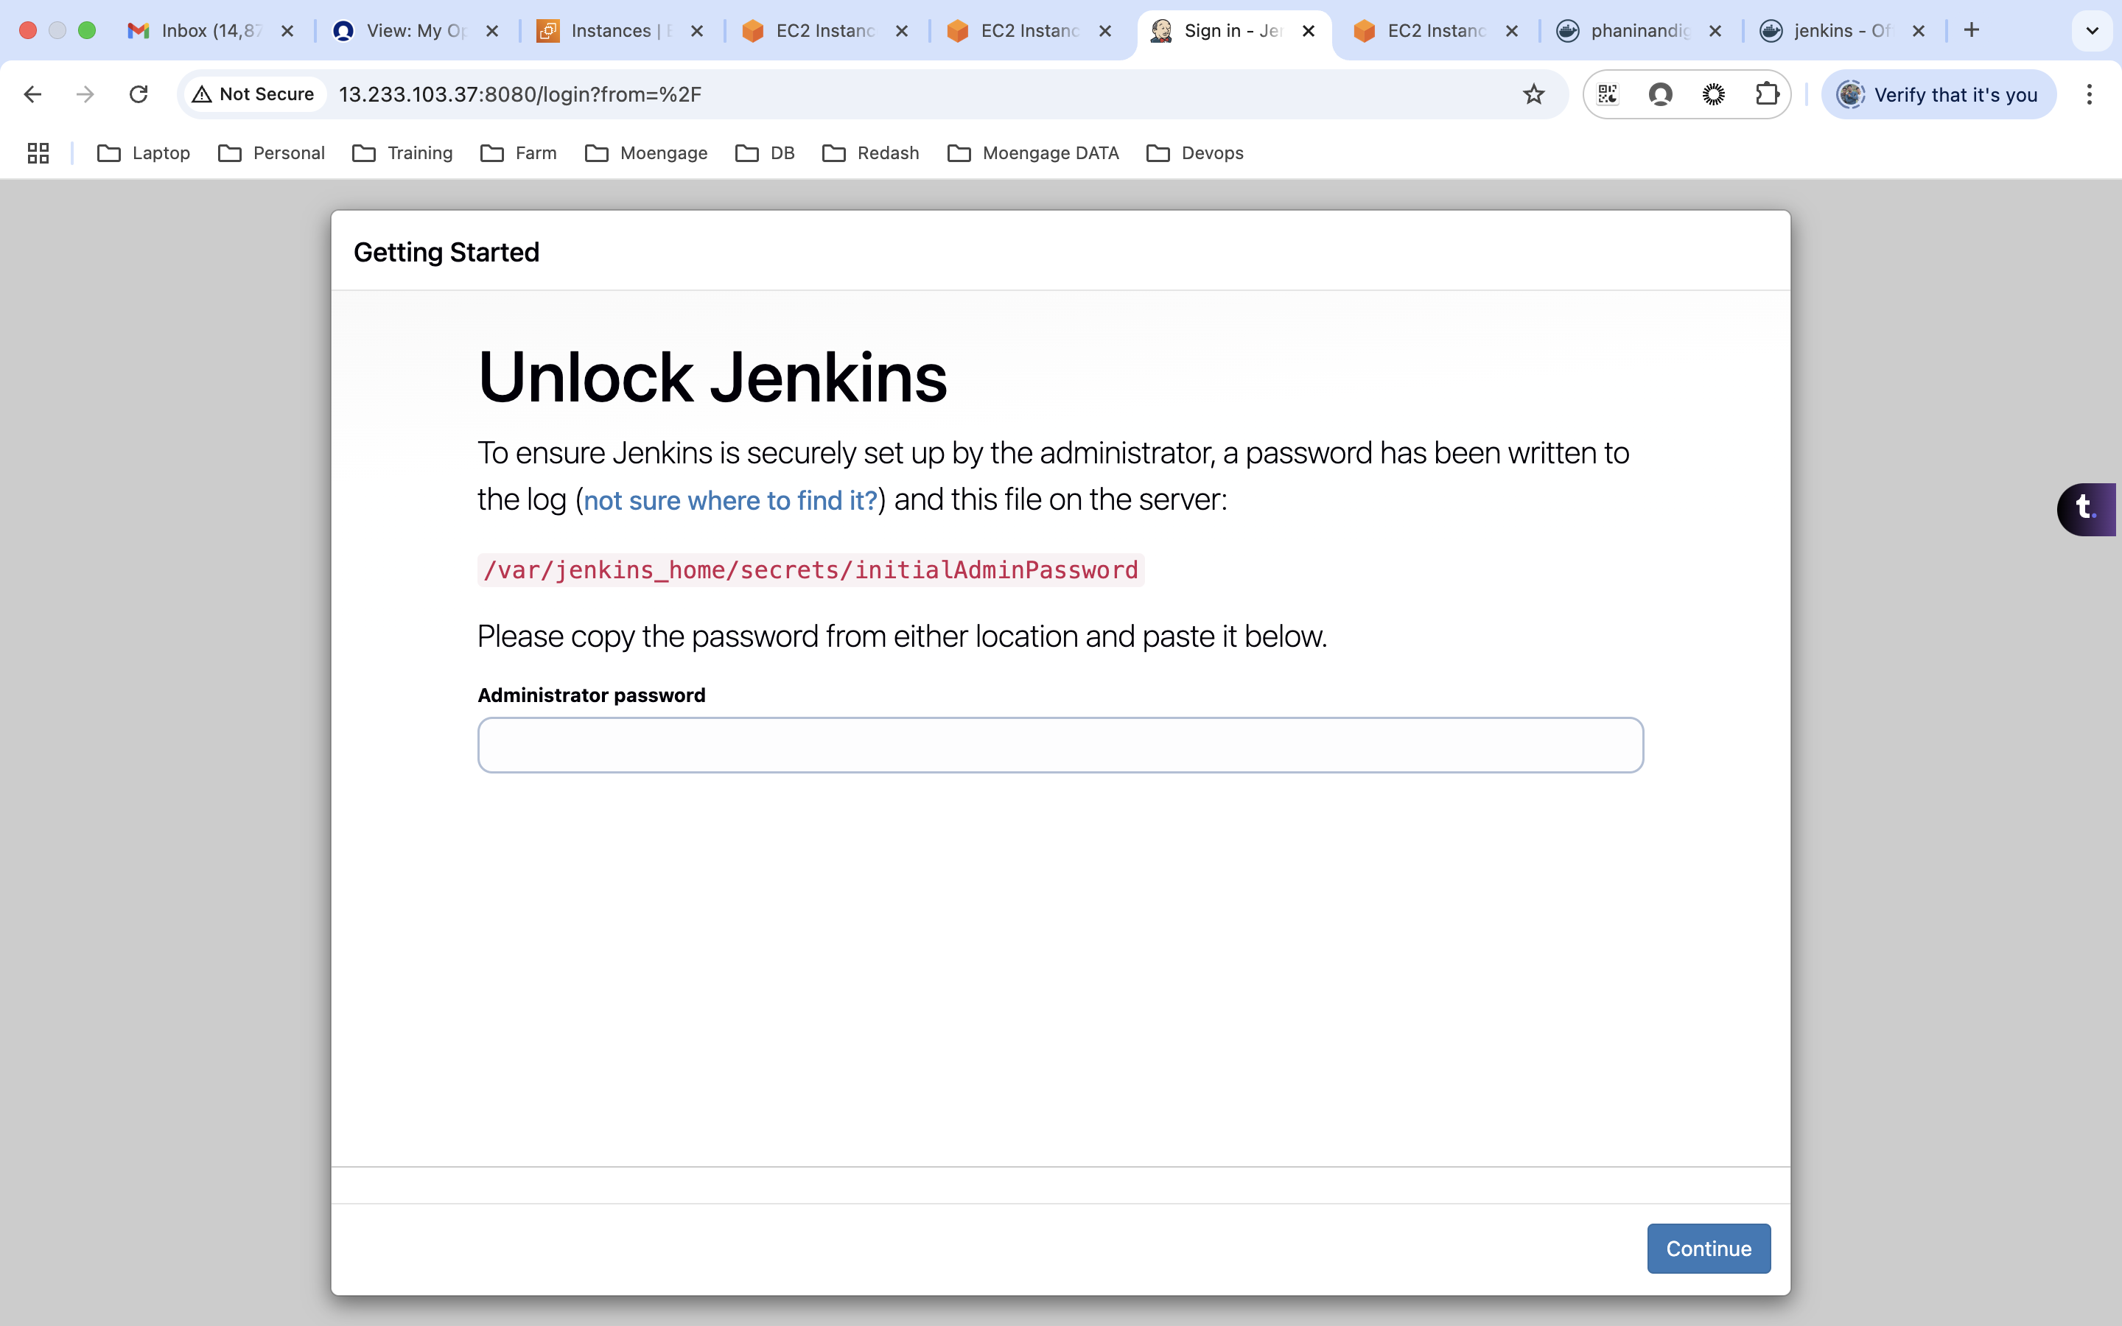
Docker Copy:
From Host to container:
docker cp localhostfile ffd3b806560f:/home/
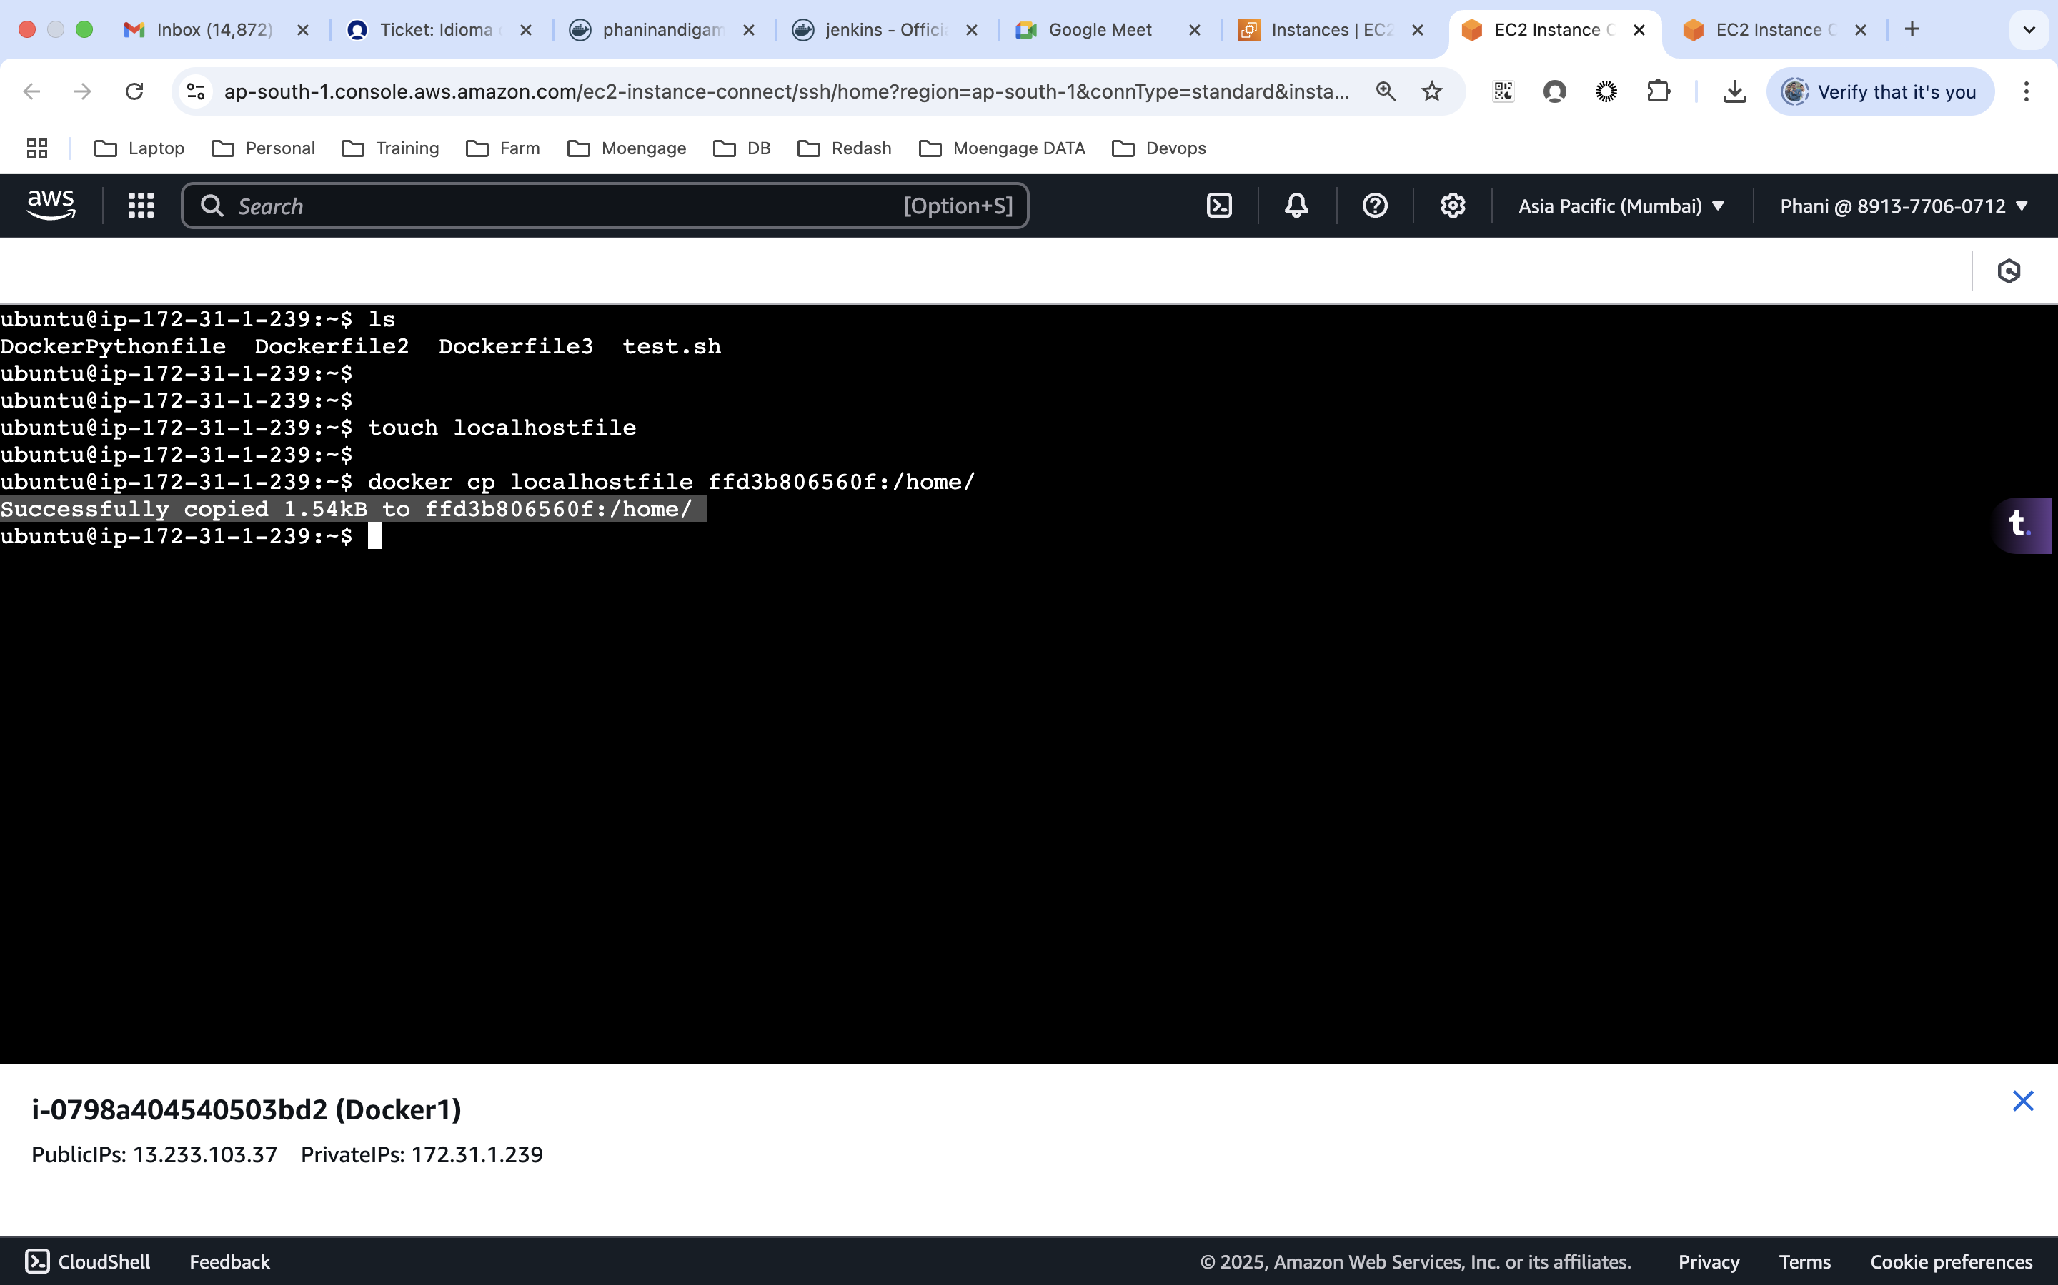

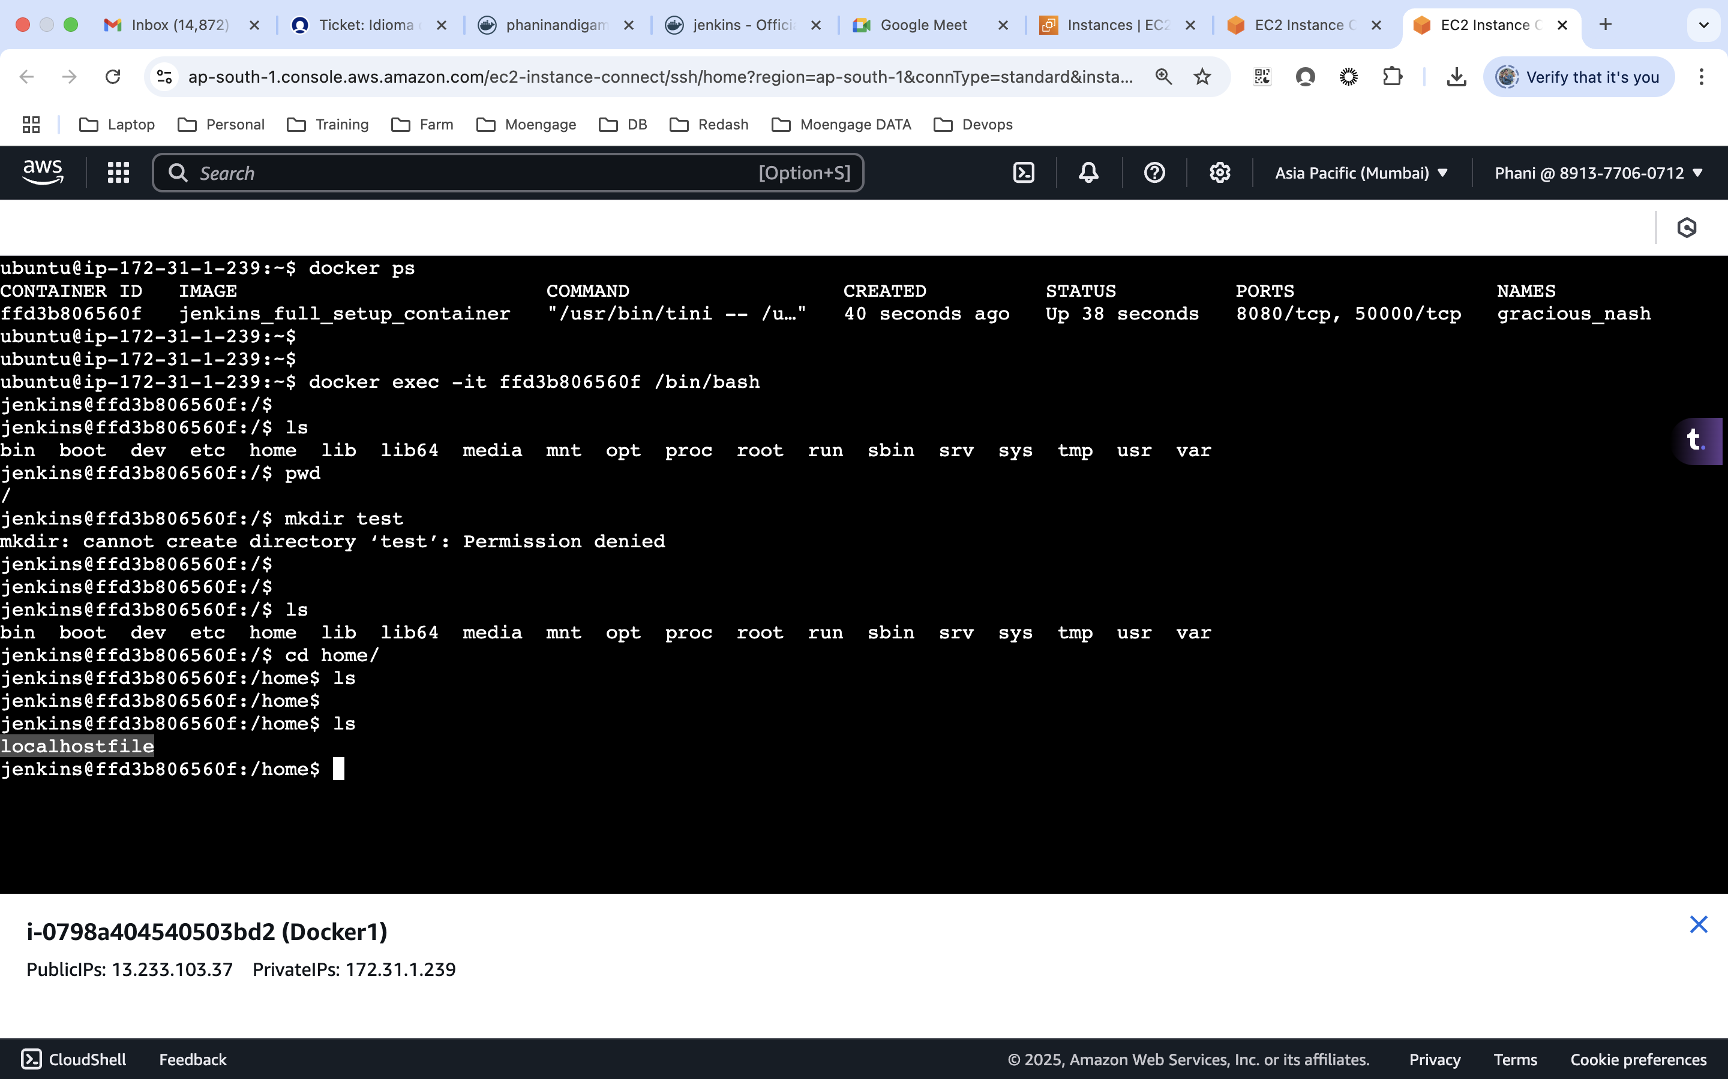

From container to the host
docker cp ffd3b806560f:/usr .
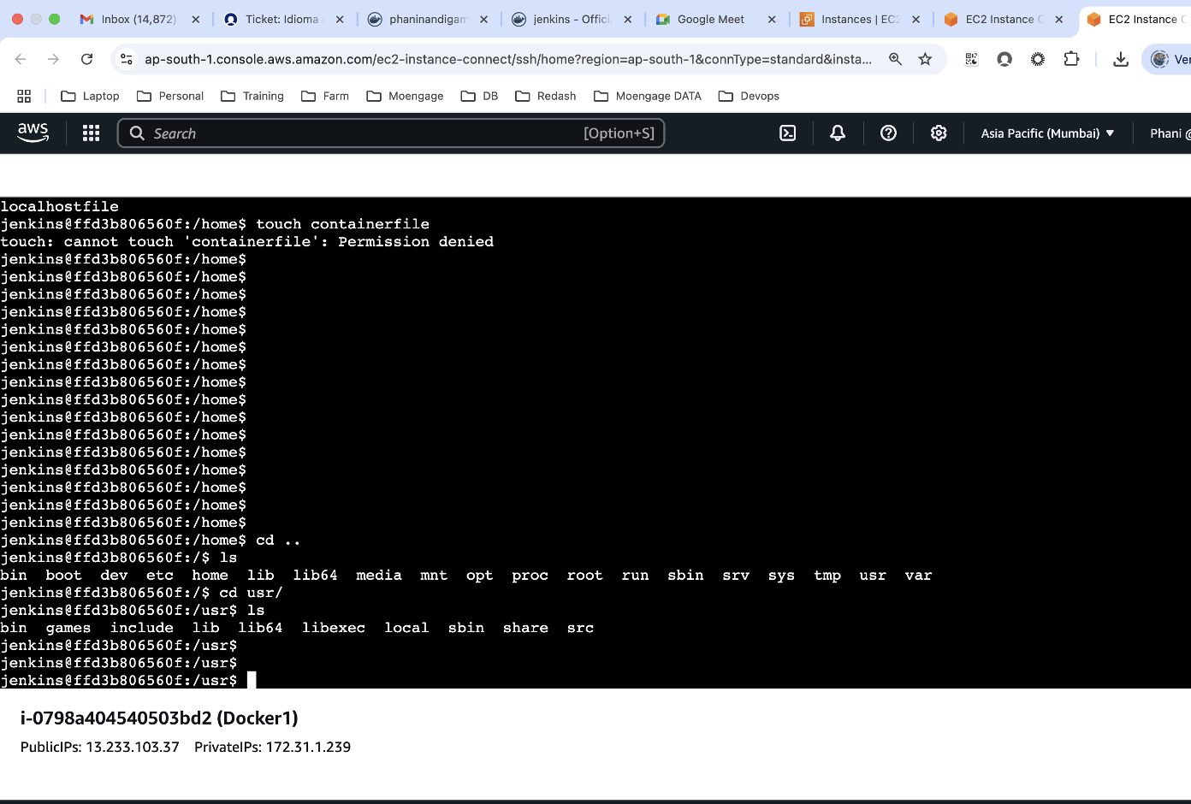
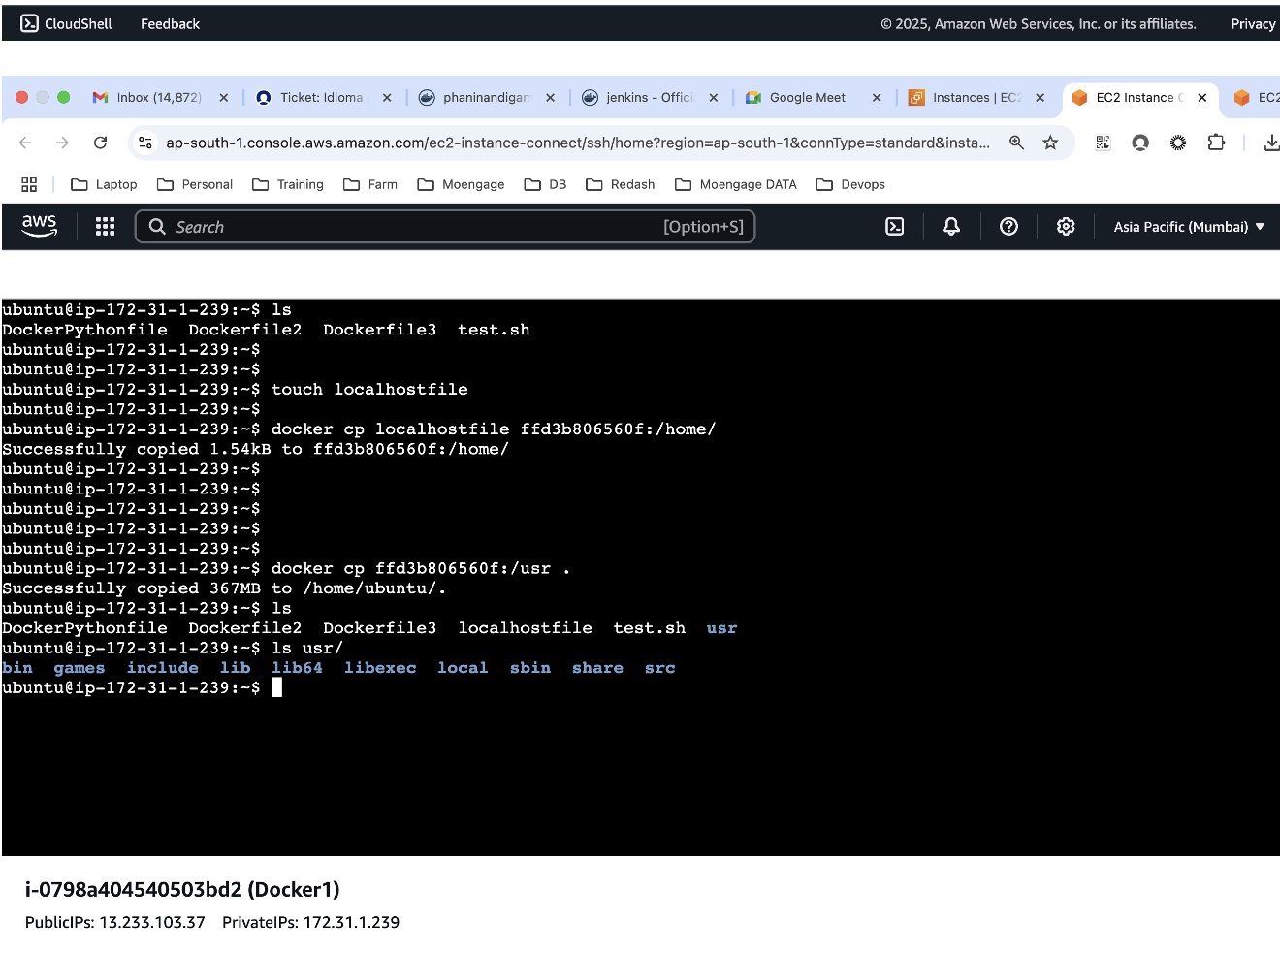

Docker Registry:
docker images
docker tag jenkins_full_setup_container:latest phaninandigam/my_jenkin_images:v1
docker images

docker login -u phaninandigam
docker push phaninandigam/my_jenkin_images:v1
